DAY 30 REPORT
TASK: Perform Data Transformation and Analytical Calculations on the Healthcare Dataset Using Power BI
Description:
Using the same Healthcare Dataset from Day 29, perform data transformation and analytical calculations in Power BI. Apply various Power BI features such as changing data types, creating new columns, generating conditional columns, creating measures, and using quick measures to enhance the dataset. Develop visualizations based on the transformed data to analyze patient demographics, billing information, and healthcare-related metrics, thereby generating meaningful insights and improving data reporting capabilities.

Operations Performed
1. Data Type Change
Column: Billing Amount
The data type of the Billing Amount column was changed from Decimal Number to Currency. This allows billing values to be displayed in a standard monetary format and improves financial data readability.
DATATYPE BEFORE:
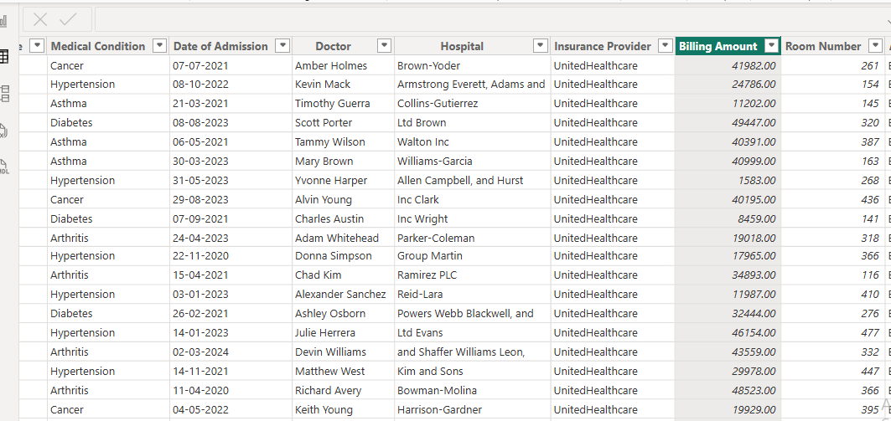
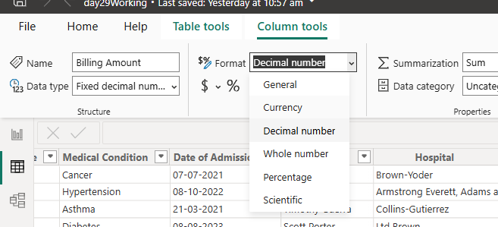
DATATYPE AFTER:
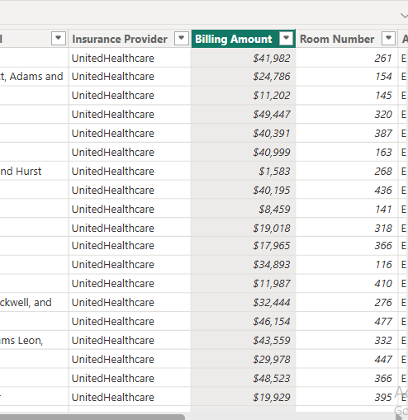
2. New Column Creation
Column Created: Age Group
A new column named Age Group was created to categorize patients into:
- Young
- Middle Aged
- Senior
This grouping helps simplify demographic analysis.

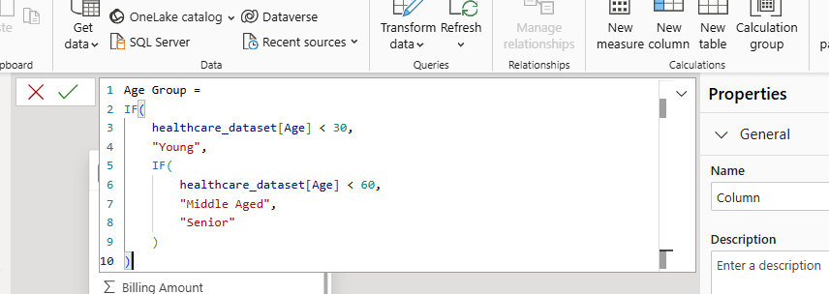
AFTER CREATING THE AGE GROUP COLUMN IT APPEARS IN THE RIGHT SIDE(PROPERTIES):
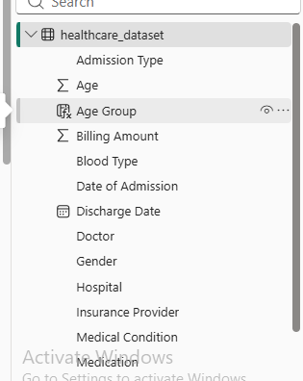
3. Conditional Column Creation
Column Created: Billing Category
A Conditional Column named Billing Category was created to classify patients into:
- High Bill
- Low Bill
based on their billing amounts.
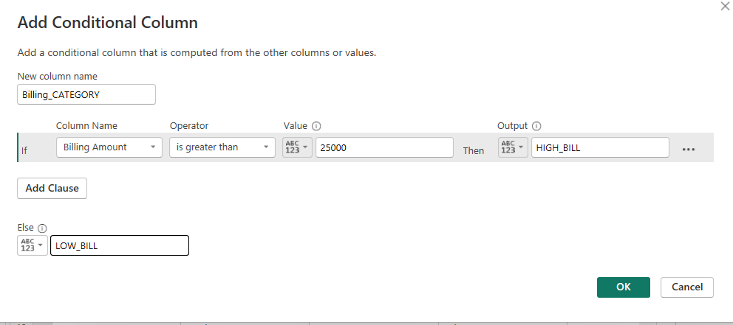
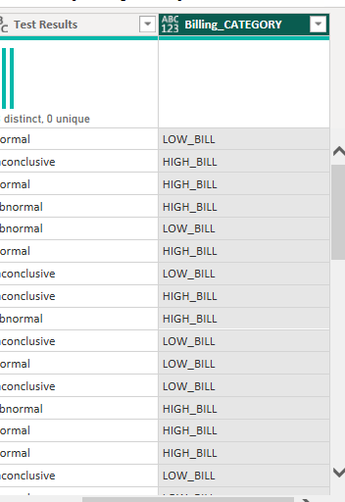
4. New Measure Creation
Measure Created: Average Billing Amount
A measure was created to calculate the average billing amount of all patients in the dataset.

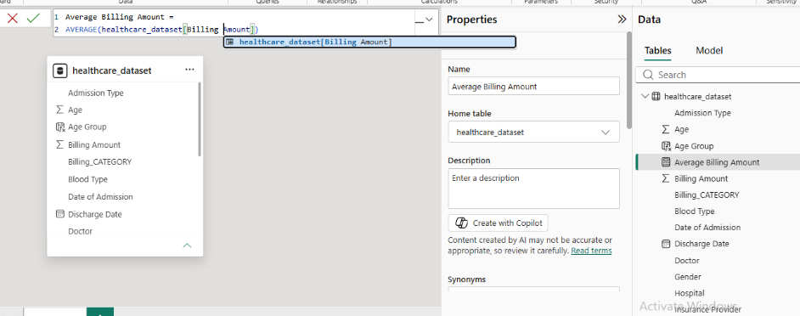
5. Quick Measure Creation
Quick Measure Created: Average Billing per Patient
A Quick Measure was created to automatically calculate the average billing amount per patient using Power BI's Quick Measure functionality.
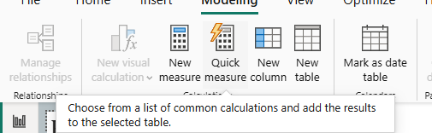
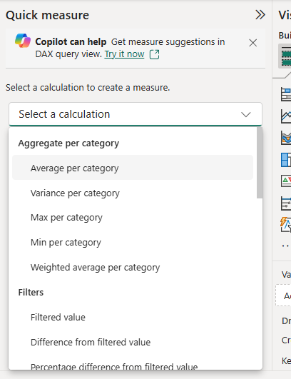
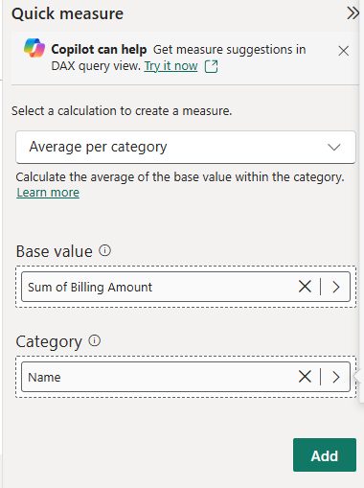

Visualizations and Analysis
1. Age Group Distribution (Donut Chart)
The Donut Chart displays the distribution of patients across different age groups.
Observation:
- Middle Aged patients account for the highest percentage of records.
- Senior patients form the second largest group.
- Young patients represent the smallest portion of the dataset.

2. Average Billing Amount (KPI Card)
A KPI Card was used to display the overall average billing amount.
Observation:
- The average billing amount is approximately ₹25.54K.
- This provides a quick overview of the average healthcare expenditure per patient.

3. Average Billing per Patient (Table Visual)
The table displays patient names along with their average billing amounts.
Observation:
- Individual patient billing information can be viewed and compared easily.
- The table helps identify patients with higher or lower average billing amounts.

4. Average Billing by Test Results (Column Chart)
This chart compares average billing amounts across different test result categories.
Observation:
- Average billing amounts for Normal, Abnormal, and Inconclusive categories are very similar.
- Healthcare expenses appear to be consistently distributed among all test result groups.

5. Billing Category Distribution (Column Chart)
This chart displays the number of patients classified under High Bill and Low Bill categories.
Observation:
- Both billing categories contain a similar number of patients.
- High Bill patients slightly outnumber Low Bill patients.

Key Insights
- The Middle Aged category contains the largest number of patients.
- Average billing amount across the dataset is approximately ₹25.54K.
- Billing amounts remain relatively consistent across different test result categories.
- High Bill and Low Bill patient counts are nearly balanced.
- Quick Measures enable efficient patient-level billing analysis.
- Converting Billing Amount to Currency improves the presentation and interpretation of financial data.
Overall dashboard:
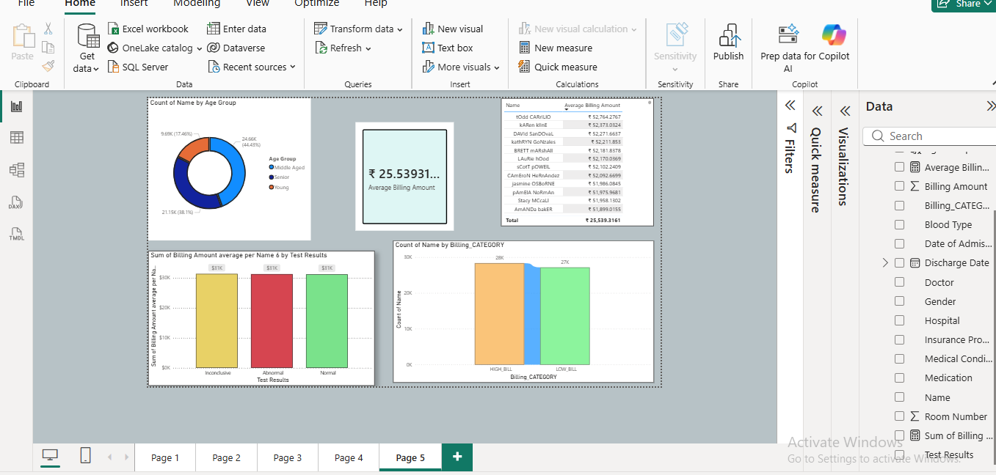

Conclusion
This task successfully demonstrated the use of Power BI data transformation and calculation features. The implementation of data type changes, new columns, conditional columns, measures, and quick measures enhanced the analytical capabilities of the dataset. The visualizations provided clear insights into patient age distribution, billing patterns, and healthcare expenses, highlighting the effectiveness of Power BI as a business intelligence and reporting tool.

